ROSSMOYNE SENIOR HIGH SCHOOL

Semester One Examination, 2013

Question/Answer Booklet

MATHEMATICS 3A
SOLUTIONS

Section One:

Calculator-free

Student Number: In figures

In words

Your name

Time allowed for this section
Reading time before commencing work: five minutes
Working time for this section: fifty minutes

Materials required/recommended for this section

To be provided by the supervisor
This Question/Answer Booklet
Formula Sheet

To be provided by the candidate
Standard items: pens, pencils, pencil sharpener, eraser, correction fluid/tape, ruler, highlighters

Special items: nil

Important note to candidates

No other items may be used in this section of the examination. It is your responsibility to ensure that you do not have any unauthorised notes or other items of a non-personal nature in the examination room. If you have any unauthorised material with you, hand it to the supervisor before reading any further.

Structure of this paper

Section | Number of questions available | Number of questions to be answered | Working time (minutes) | Marks available | Percentage of exam
Section One:  Calculator-free | 7 | 7 | 50 | 50 | 33
Section Two:  Calculator-assumed | 13 | 13 | 100 | 100 | 67
 |  |  | Total | 150 | 100

Instructions to candidates

- The rules for the conduct of Western Australian external examinations are detailed in the Year 12 Information Handbook 2013. Sitting this examination implies that you agree to abide by these rules.

- Write your answers in the spaces provided in this Question/Answer Booklet. Spare pages are included at the end of this booklet. They can be used for planning your responses and/or as additional space if required to continue an answer.
- Planning: If you use the spare pages for planning, indicate this clearly at the top of the page.
- Continuing an answer: If you need to use the space to continue an answer, indicate in the original answer space where the answer is continued, i.e. give the page number. Fill in the number of the question(s) that you are continuing to answer at the top of the page.

- Show all your working clearly. Your working should be in sufficient detail to allow your answers to be checked readily and for marks to be awarded for reasoning. Incorrect answers given without supporting reasoning cannot be allocated any marks. For any question or part question worth more than two marks, valid working or justification is required to receive full marks. If you repeat an answer to any question, ensure that you cancel the answer you do not wish to have marked.

- It is recommended that you do not use pencil, except in diagrams.

Section One: Calculator-free (50 Marks)
This section has seven (7) questions. Answer all questions. Write your answers in the spaces provided.

Working time for this section is 50 minutes.

Question 1 (5 marks)
(a) Expand 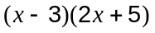 (1 mark)

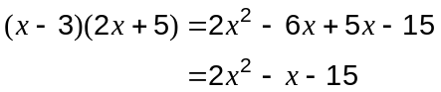

(b) Solve 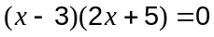 (2 marks)

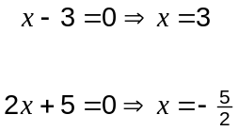

(c) Factorise 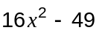. (2 marks)

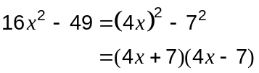

Question 2 (8 marks)
(a) Evaluate

(i) 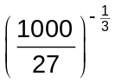 (2 marks)
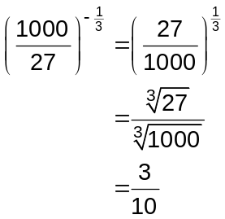

(ii) 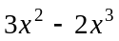 when 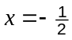. (2 marks)

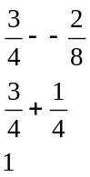

(b) Solve for

(i) 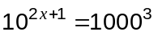 (2 marks)
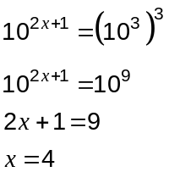

(ii) 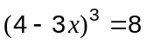 (2 marks)
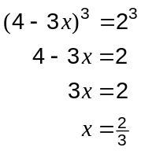
Question 3 (9 marks)
The three functions below have been graphed over the domain 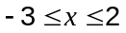.

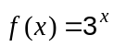 | 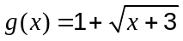 | 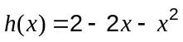
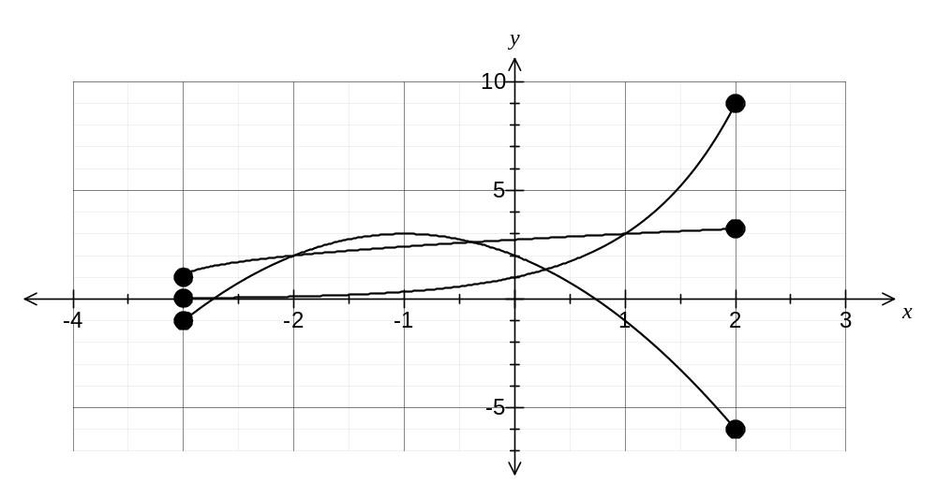
(a) Over the given domain, state the range of

(i)  (2 marks)
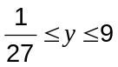

(ii) 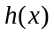 (2 marks)
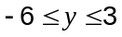

(b) Which function has symmetry when graphed over its natural domain? (1 mark)

(c) State which function has an asymptote and write down it's equation.
(2 marks)
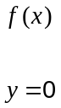

(d) Use the graph to estimate all solutions to 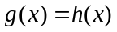. (2 marks)
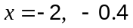

Question 4 (8 marks)
At 9.00 am, a mother leaves her home and walks at a steady 3 km h⁻¹ along a cycle path towards a lake 3 km away, where her son is playing.

At 9.20 am her son leaves the lake to cycle home, but 10 minutes later, after cycling 1 km, he stops for 25 minutes. He then continues home at a steady speed, which he reaches at 10.05 am. Part of his cycle is shown on the graph below.
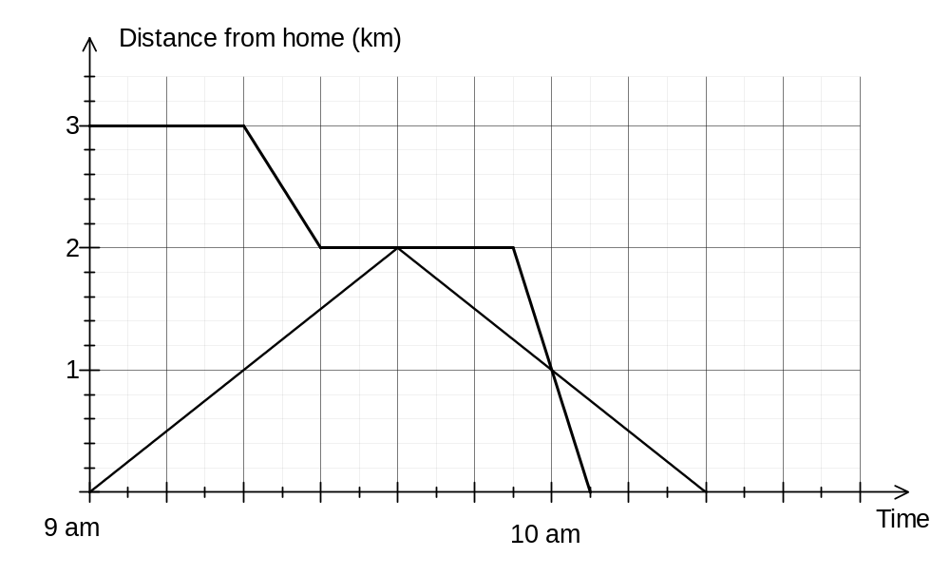
(a) Complete the travel graph for the son. (1 mark)

(b) Determine the speed at which the son cycled home after his 25 minute stop in

(i) kilometres per hour (1 mark)
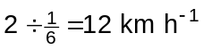

(ii) metres per second (2 marks)
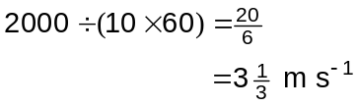

(c) As soon as the mother met her son, she turned around and continued home, again at a steady 3 km h⁻¹. Draw the travel graph for the mother on the axes above. (2 marks)

(d) At what time should the boy's sister leave home, walking at 4 km h⁻¹, in order to meet her brother at the instant he cycles past his mother on her way home? (2 marks)

Question 5 (6 marks)
(a) At a hardware store, the lengths of a large number of planks marked as 3 m long, were actually normally distributed with a mean of 302 cm and a standard deviation of 3 cm.

(i) State the median length of the planks. (1 mark)

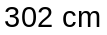

(ii) Find the probability that the length of a randomly chosen plank is between 296 cm and 308 cm. (1 mark)
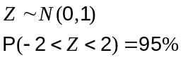

(iii) Find the probability that the length of a randomly chosen plank is less than 2.99 m.
(2 marks)
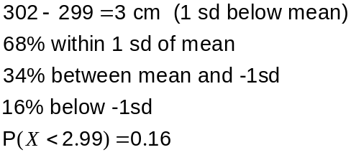

(b) The same store was concerned about a possible rat infestation in the timber yard. One day, six rats were caught in traps, tagged and released. A few days later, more traps were set and out of 19 rats caught, two were tagged.

Use this information to estimate the number of rats in the timber yard. (2 marks)

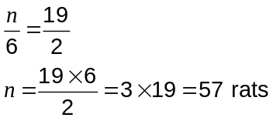

Question 6 (8 marks)
(a)
(i) Draw the graph of.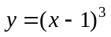 (3 marks)
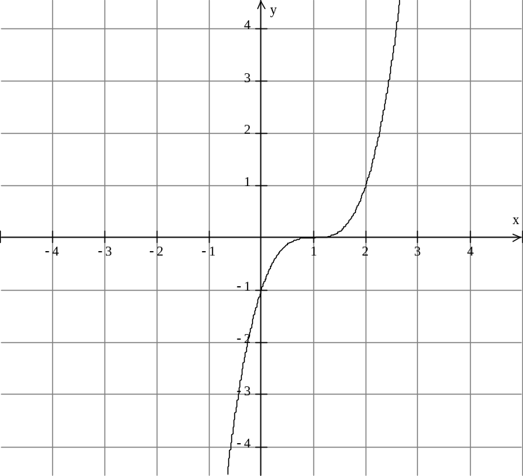
(ii) State the coordinates, if any, of the point(s) of inflection of the curve .
If there are none, explain why. (1 mark)
At (1, 0)

(b)
(i) Draw the graph of 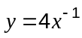. (3 marks)
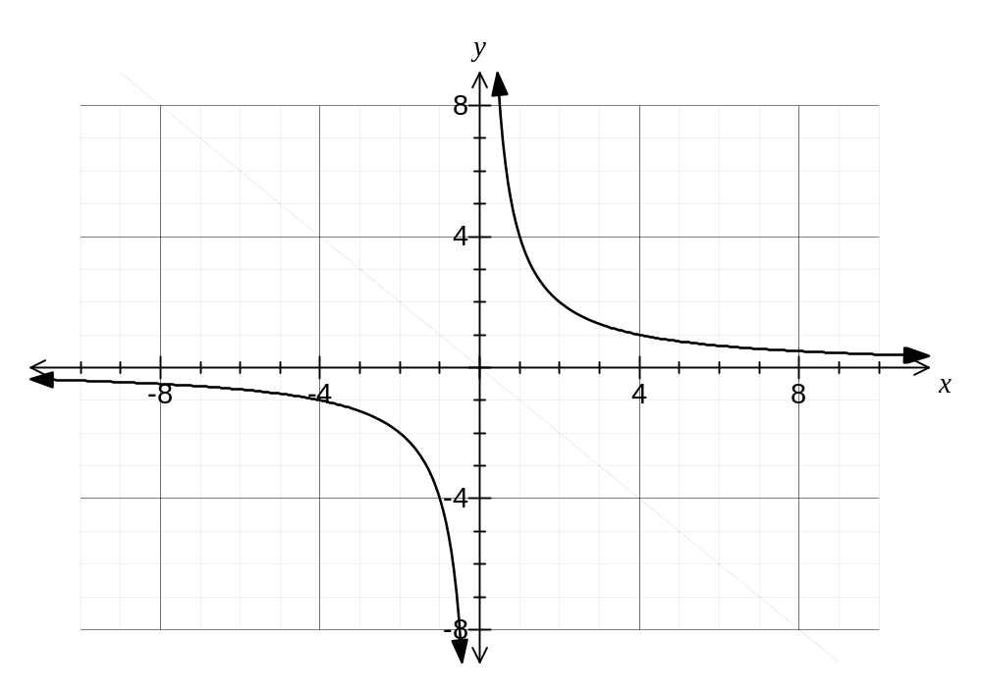
(ii) Explain, using your graph, why there are no solutions to the equation 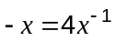.
(1 mark)
Dotted line is 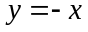 and there is no intersection with , so no solution to equation.

Question 7 (6 marks)
(a) In triangle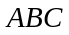, 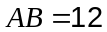cm, 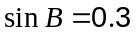 and 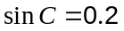.

Determine the length of side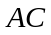. (3 marks)

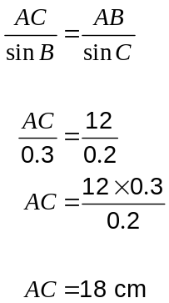

(b) In triangle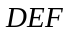,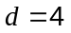cm, 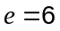cm and 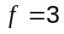cm.

Determine the value of 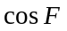. (3 marks)
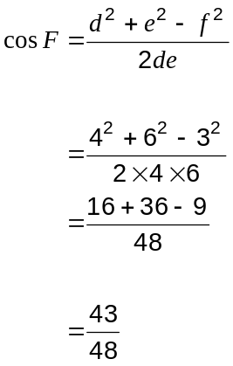

Additional working space

Question number: _________

Additional working space

Question number: _________

This examination paper may be freely copied, or communicated on an intranet, for non-commercial purposes within educational institutes that have purchased the paper from WA Examination Papers provided that WA Examination Papers is acknowledged as the copyright owner. Teachers within purchasing schools may change the paper provided that WA Examination Paper's moral rights are not infringed.

Copying or communication for any other purposes can only be done within the terms of the Copyright Act or with prior written permission of WA Examination papers.

Published by WA Examination Papers
PO Box 445 Claremont WA 6910

